## Use Case UML

@startuml

title Use Case Diagram for File Classifier

actor User as user

actor UploadAgent as uploadAgent

actor ClassifierAgent as classifierAgent

actor MoveFileAgent as moveFileAgent

actor ViewFileAgent as viewFileAgent

user -- (Upload Files) : <<upload>>

user -- (View Files) : <<view>>

uploadAgent -- (Receive Files for Classification) : <<classify>>

uploadAgent -- (Pass Files for Classification) : <<classify>>

classifierAgent -- (Classify Files) : <<classify>>

classifierAgent -- (Pass Safe Files) : <<move>>

classifierAgent -- (Pass Suspicious Files) : <<move>>

moveFileAgent -- (Move Safe Files to Safe Folder) : <<move>>

moveFileAgent -- (Move Suspicious Files to Suspicious Folder) : <<move>>

viewFileAgent -- (Display Safe Files) : <<view>>

viewFileAgent -- (Display Suspicious Files) : <<view>>

uploadAgent --> classifierAgent : <<classify>>

classifierAgent --> moveFileAgent : <<move>>

classifierAgent --> viewFileAgent : <<view>>

@enduml

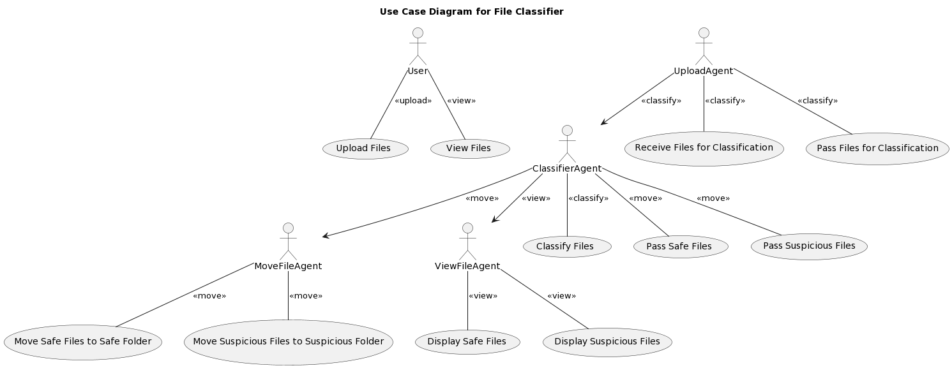

## Sequential UML Diagram

@startuml

actor User

actor UploadAgent as UA

actor ClassifierAgent as CA

actor MoveFileAgent as MA

actor ViewFileAgent as VA

User -> UA: Upload Files

User -> VA: View Files

UA -> CA: Receive Files for Classification

UA -> CA: Pass Files for Classification

CA -> MA: Classify Files

MA -> MA: Move Safe Files to Safe Folder

MA -> MA: Move Suspicious Files to Suspicious Folder

VA -> VA: Display Safe Files

VA -> VA: Display Suspicious Files

@enduml

